A

TECHNICAL SEMINAR REPORT

on

GEN-AI CONTENT RETRIEVAL

BACHELOR OF TECHNOLOGY
In

COMPUTER SCIENCE AND ENGINEERING ( ARTIFICIAL INTELLIGENCE AND MACHINE LEARNING )

Submitted By

(BATCH 2022 - 2026)

MOGILI SAINATH - (227Y1A66A2)

UNDER THE GUIDANCE OF
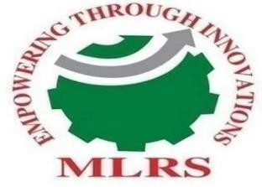
MR. K.SRIKANTH
Assistant Professor

DEPARTMENT OF COMPUTER SCIENCE AND ENGINEERING ( ARTIFICIAL INTELLIGENCE AND MACHINE LEARNING)

MARRI LAXMAN REDDY INSTITUTE OF TECHNOLOGY AND MANAGEMENT

(UGC – AUTONOMOUS)

(Affiliated to JNTUH, Approved by AICTE, New Delhi and Accredited by NBA & NAAC with ‘A’ Grade)
2026

CERTIFICATE

This is to certify that the Technical Seminar entitled “GEN-AI CONTENT RETRIEVAL” work done by MOGILI SAINATH (227Y1A66A2) student of Department of Computer Science and Engineering (AI-ML), is a record of bonafide work carried out by the members under the supervision of Mrs. K. Kavitha This Technical Seminar is done as a fulfillment of obtaining Bachelor of Technology to be awarded by Jawaharlal Nehru Technological University Hyderabad, Hyderabad.The matter embodied in this Technical Seminar report has not been submitted by us to any other university for the award of any other degree.

Mr. K. SRIKANTH Dr. B. RAVI PRASAD
Internal Guide Head of the Department

Dr. R. MURALI PRASAD External Examiner
Principal

DECLARATION

I hereby declare that the Technical Seminar Report entitled, “GEN-AI CONTENT RETRIEVAL” submitted for the B.Tech. degree is entirely my work and all ideas and references have been duly acknowledged. It does not contain any work for the award of any other degree.

Date:

MOGILI SAINATH (227Y1A66A2)
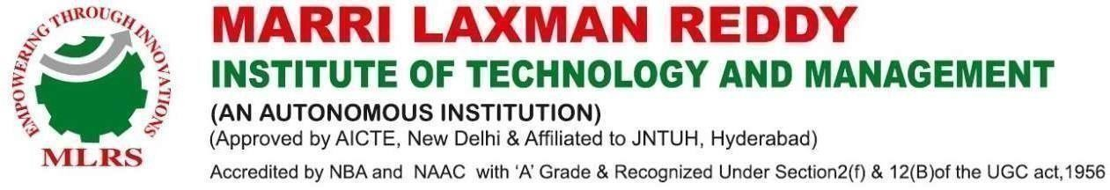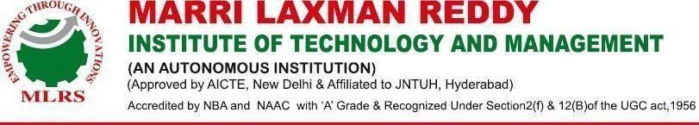

ACKNOWLEDGEMENT

I am happy to express my deep sense of gratitude to the Principal of the college, Dr. R. Murali Prasad, Professor, Marri Laxman Reddy Institute of Technology & Management, for providing me with adequate facilities to pursue my technical seminar.

I would like to thank Dr. B. Ravi Prasad, Dean of Academics, Professor and Head of the Department of Computer Science and Engineering (Artificial Intelligence and Machine Learning), Marri Laxman Reddy Institute of Technology & Management, for giving me the freedom to utilize all the facilities available in the department, especially the laboratories and library.

I am extremely grateful to my technical seminar guide, Mr. K. Srikanth, Assistant Professor, Department of Computer Science and Engineering (Artificial Intelligence and Machine Learning), Marri Laxman Reddy Institute of Technology & Management, for his valuable guidance, continuous support, and patience throughout the course of my technical seminar work.

I sincerely thank my seniors and all the teaching and non-teaching staff of the Department of Computer Science and Engineering (AIML) for their timely suggestions, constructive criticism, and constant motivation during the course of this work.

I would also like to thank my classmates for always being there whenever I needed help or moral support.
With great respect and gratitude, I thank my parents and guardians who have always been the backbone behind my achievements.

Finally, I express my sincere gratitude to all the individuals who have directly or indirectly contributed to the successful completion of this work.



ABSTRACT

Generative Artificial Intelligence (Gen-AI) has emerged as a powerful technology capable of producing human-like text, images, and other forms of content. However, retrieving accurate and relevant information from large volumes of data remains a major challenge. The Gen-AI Content Retrieval system aims to improve the process of searching, understanding, and generating meaningful responses from large datasets using advanced AI techniques.
This project focuses on integrating Generative AI with intelligent information retrieval mechanisms to provide efficient and context-aware results. The system uses Natural Language Processing (NLP) and Large Language Models (LLMs) to understand user queries in natural language and retrieve the most relevant information from structured and unstructured data sources. By combining semantic search techniques with generative models, the system not only retrieves information but also summarizes and presents it in a clear and human-readable format.
The proposed system enhances the traditional search process by improving accuracy, reducing irrelevant results, and providing quick insights from large datasets. This approach can be applied in various domains such as education, research, healthcare, and knowledge management systems. Overall, the Gen-AI Content Retrieval system demonstrates how modern AI technologies can significantly improve information access and knowledge discovery in the digital era.

